**Lab Record**

**of**

**OOP**

(**01CT0105**)



**Submitted to :-Submitted by :-**

Dr. Chirag Joshi Aryan Dilipbhai Langhanoja

Assistant Professor 92200133030

Dept of ICT ICT – 2TK1

MU 2nd Semester

|  |  |  |
| --- | --- | --- |
| Image result for latest marwadi university logo | **Marwadi University**  **Faculty of Technology**  **Department of Information and Communication Technology** | |
| **Subject:- OOP  (01CT0105)** | **Aim:-** Write a Java program that prompts the user for an integer and then prints out all the prime numbers up to that Integer. | |
| **Experiment No:-** 1 | **Date:-**  03-03-2023 | **Enrolment No:- 92200133030** |

**Experiment – 1**

**Objective :**- Write a Java program that prompts the user for an integer and then prints out

all the prime numbers up to that Integer.

**Code:-**

import java.util.*;

public class Programm1

{

public static void main(String args[])

{

Scanner sc = new Scanner (System.in);

int n,j,i;

System.out.print("Enter The Number:-");

n = sc.nextInt();

for(i=2;i<=n;i++){

for(j=2;j<i;j++){

if(i%j==0){

break;

}}

if(i==j){

System.out.print(i + " ");

}}}}

**Output:-**

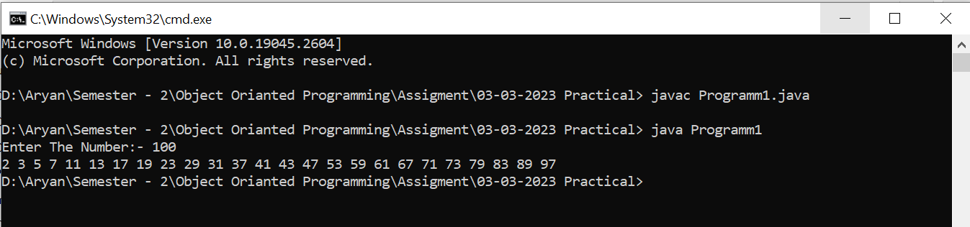

|  |  |  |  |
| --- | --- | --- | --- |
|  | | | |
| Image result for latest marwadi university logo | Marwadi University  Faculty of Technology  Department of Information and Communication Technology | | |
| **Subject:- OOP  (01CT0105)** | **Aim:-** Write a Java program that prompts the user for an integer and then prints out all the prime numbers up to that Integer. | | |
| **Experiment No:-** 2 | **Date:-**  03-03-2023 | **Enrolment No:- 92200133030** | |

**Experiment – 2**

**Objective :**- Write a java program to find the Fibonacci series using non-recursive  
Functions.

**Code:-**

import java.util.*;

public class Programm2

{

public static void main (String args[])

{

Scanner sc = new Scanner (System.in);

int a=0,b=1,num;

System.out.print("Enter Till How Many Terms You Want The Fibonacci Series ?");

num = sc.nextInt();

System.out.print(a + " " + b + " ");

Fibonacci(num); }

public static void Fibonacci(int num)

{

int a=0,b=1,c;

for(int i=1;i<=num;i++) {

c = a + b;

System.out.print(c + " ");

a=b;

b=c; } } }

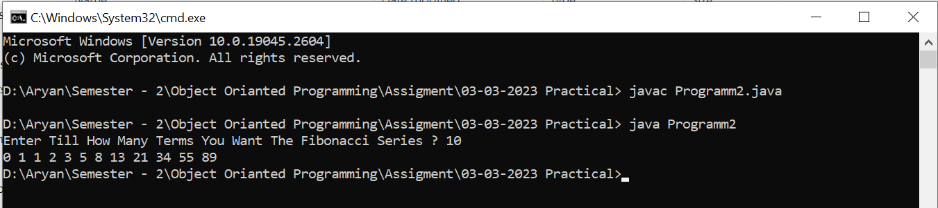 **Output:-**

|  |  |  |
| --- | --- | --- |
| Image result for latest marwadi university logo | **Marwadi University**  **Faculty of Technology**  **Department of Information and Communication Technology** | |
| **Subject:- OOP  (01CT0105)** | **Aim:-** Write a java program to find the Fibonacci series using recursive Functions. | |
| **Experiment No:-** 3 | **Date:-**  03-03-2023 | **Enrolment No:- 92200133030** |

**Experiment – 3**

**Objective :**- Write a java program to find the Fibonacci series using recursive Functions.

**Code:-**

import java.util.* ;

public class Programm3

{public static void main(String args[]){

Scanner sc =new Scanner (System.in);

int num,a=0,b=1;

System.out.println("Enter Till How Many Terms You Want The Fibonacci Series?");

num = sc.nextInt();

System.out.print(0 + " " + 1 + " ");

int c = Fibonacci(a,b,num);

System.out.print(c + " "); }

public static int Fibonacci(int x,int y,int num){

num--;

int z=x+y;

if(num<=2) { return x + y ; }

else {

System.out.print(z + " ");

return Fibonacci(y,z,num) ; }}}

**Output:-**

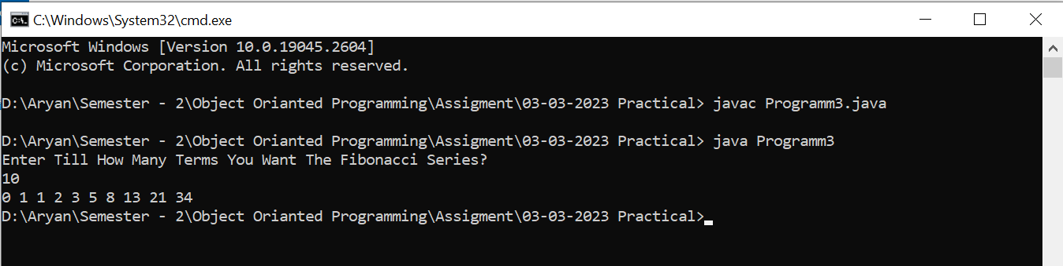

|  |  |  |
| --- | --- | --- |
| Image result for latest marwadi university logo | **Marwadi University**  **Faculty of Technology**  **Department of Information and Communication Technology** | |
| **Subject:- OOP  (01CT0105)** | **Aim:-** Write a java program to display the employee details using Scanner class. | |
| **Experiment No:-** 4 | **Date:-**  10-03-2023 | **Enrolment No:- 92200133030** |

**Experiment – 4**

**Objective :**- Write a java program to display the employee details using Scanner class.

**Code:-**

import java.util.*;

class Employee_Detail

{ String Name;

String Post;

String Location;

int age;

int salary ;

public static void Details(int n)

{ for(int i=0;i<n;i++){

System.out.print("Enter The Name Of Employee-" + i+1 +":-");

Employye[i].Name = sc.nextLine();

System.out.print("Enter The Post Of Employee-" + i+1 +":-");

Employye[i].Post = sc.nextLine();

System.out.print("Enter The Location Of Employee-" + i+1 +":-");

Employye[i].Location = sc.nextLine();

System.out.print("Enter The Age Of Employee-" + i+! +":-");

Employye1[i].age = sc.nextInt();

System.out.print("Enter The Salary Of Employee-" + i+1 +":-");

Employye[i].salary = sc.nextInt(); }}

public static void print(int n) { for(int j=0;j<n;j++) {

System.out.println("Employee Details:-\nName:- "+ Employye[i].Name + "\nPost:- " + Employye[i].Post + "\nLOcation:- " + Employye[i].Location+ "\nAge:- "+ Employye[i].age +" Years" + "\nSalary:- Rs " + Employye[i].salary + " /-"); }}}

public class Programm1

{ public static void main(String args[]) {

Scanner sc = new Scanner(System.in);

System.out.print("How Many Employee's etail You Want To Save:-");

int num = sc.nextInt();

Employee_Detail Employye[] = new Employee_Detail [num];

Employee_Detail.Details(num);

Employee_Detail.print(num); }}

**Output:-**

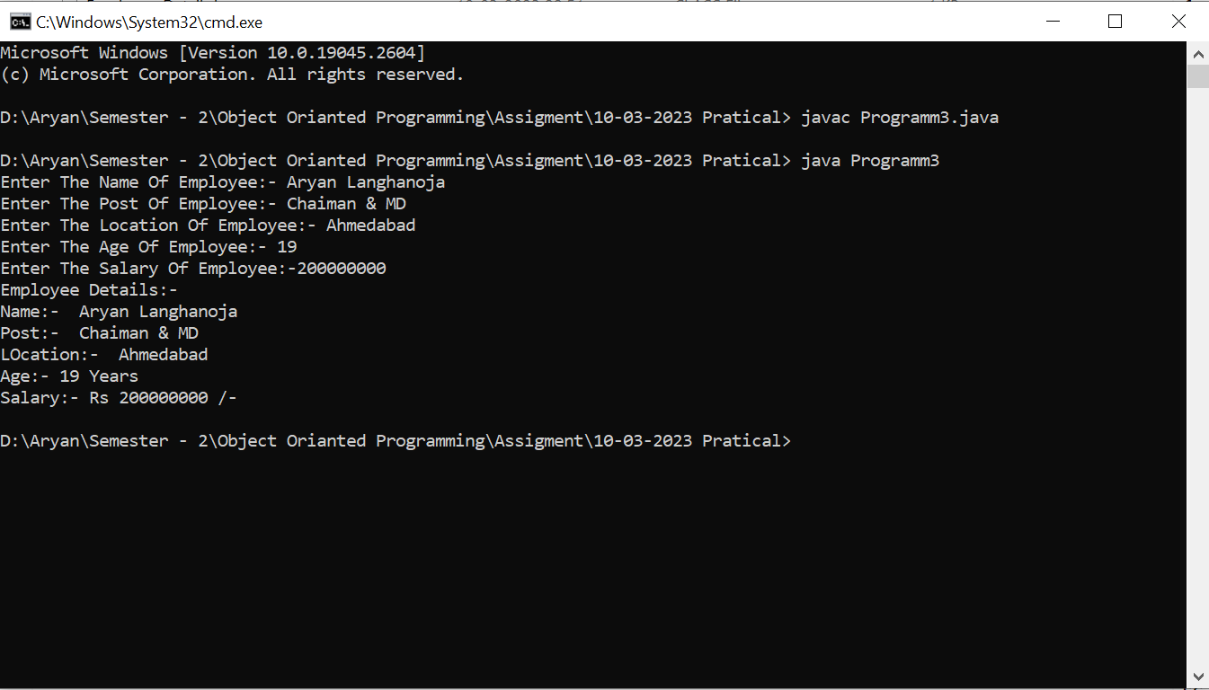

|  |  |  |
| --- | --- | --- |
| Image result for latest marwadi university logo | **Marwadi University**  **Faculty of Technology**  **Department of Information and Communication Technology** | |
| **Subject:- OOP  (01CT0105)** | **Aim:-** Write a java program that checks whether a given string is palindrome or not. | |
| **Experiment No:-** 5 | **Date:-**  10-03-2023 | **Enrolment No:- 92200133030** |

**Experiment – 5**

**Objective :**- Write a java program that checks whether a given string is palindrome or not.

**Code:-**

import java.util.*;

public class Programm2

{public static void main(String args[]){

Scanner sc = new Scanner (System.in);

String A,B;

System.out.print("Enter The First String:-");

A = sc.nextLine();

B=new StringBuilder(A).reverse().toString();

if(A.equals(B))

System.out.print("Palindrome");

else

System.out.print("Not Pelindrome"); }}

**Output:-**

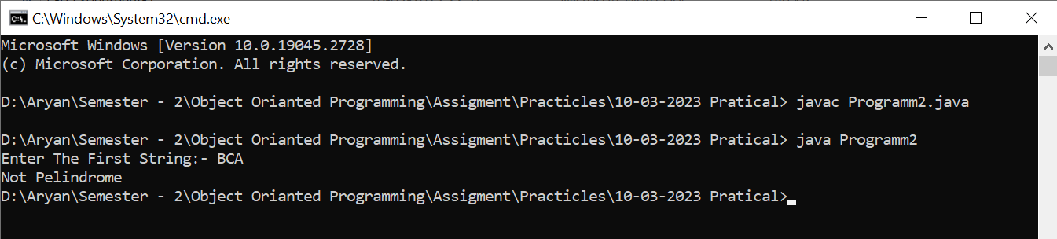

|  |  |  |
| --- | --- | --- |
| Image result for latest marwadi university logo | **Marwadi University**  **Faculty of Technology**  **Department of Information and Communication Technology** | |
| **Subject:- OOP  (01CT0105)** | **Aim:-** Write a Java Program to implement all types of Inheritance. | |
| **Experiment No:-** 6 | **Date:-**  07-04-2023 | **Enrolment No:- 92200133030** |

**Experiment – 6**

**Objective :**- Write a Java Program to implement all types of Inheritance.

**Code:-**

import java.util.*;

class Parent_Class {

int num1;

int num2;

public void Add(int num1,int num2) {

this.num1 = num1 ;

this.num2 = num2 ;

System.out.println("This Is A Method Of Patent Class");

System.out.println("The Addition Of " + this.num1 + " and " + this.num2 + " Is " + (this.num1 + this.num2)); }}

class Child_Class_1 extends Parent_Class {

int num3;

public void Add(int num1,int num2,int num3) {

this.num1 = num1;

this.num2 = num2 ;

this.num3 = num3 ;

System.out.println("This Is A Method Of Child Class-1");

System.out.println("The Addition Of " + this.num1 + " , " + this.num2 + "and " + this.num3 + " Is " + (this.num1 + this.num2 + this.num3)); }}

class Child_Class_2 extends Parent_Class {

int num4;

public void Add(int num1,int num2,int num4) {

this.num1 = num1 ;

this.num2 = num2 ;

this.num4 = num4 ;

System.out.println("This Is A Method Of Child Class-2");

System.out.println("The Addition Of " + this.num1 + " , " + this.num2 + "and " + this.num4 + " Is " + (this.num1 + this.num2 + this.num4)); }}

class Grand_Child extends Child_Class_1 {

int num5;

public void Add (int num1 , int num2 , int num3 , int num5) {

System.out.println("This Is A Method Of Grand Child Class:-");

System.out.println("The Addition Of " + this.num1 + " , " + this.num2 + "and " + this.num3 + " , "+ this.num5 + "" + " Is " + (this.num1 + this.num2 + this.num3 + this.num5)); }}

public class Programm_1

{ public static void main(String[] args) {

Scanner sc = new Scanner(System.in) ;

Parent_Class P = new Parent_Class();

Child_Class_1 C1 = new Child_Class_1();

Child_Class_2 C2 = new Child_Class_2() ;

Grand_Child G = new Grand_Child();

System.out.print("Enter The Number-1:-");

P.num1 = sc.nextInt();

System.out.print("Enter The Number-2:-");

P.num2 = sc.nextInt() ;

System.out.print("Enter The Number-3:-");

C1.num3 = sc.nextInt() ;

C1.num1 = P.num1 ;

C1.num2 = P.num2 ;

System.out.print("Enter The Number-4:-");

C2.num4 = sc.nextInt() ;

C2.num1 = P.num1 ;

C2.num2 = P.num2 ;

System.out.print("Enter The Number-5:-");

G.num5 = sc.nextInt() ;

G.num3 = C1.num3 ;

G.num1 = P.num1 ;

G.num2 = P.num2 ;

P.Add(P.num1, P.num2);

C1.Add(C1.num1, C1.num2, C1.num3);

C1.Add(C1.num1, C1.num2);

C2.Add(C2.num1, C2.num2, C2.num4);

C2.Add(C2.num1, C2.num2);

G.Add(G.num1, G.num2);

G.Add(G.num1, G.num2, G.num3);

G.Add(G.num1, G.num2, G.num3, G.num5);

sc.close(); }}

**Output:-**

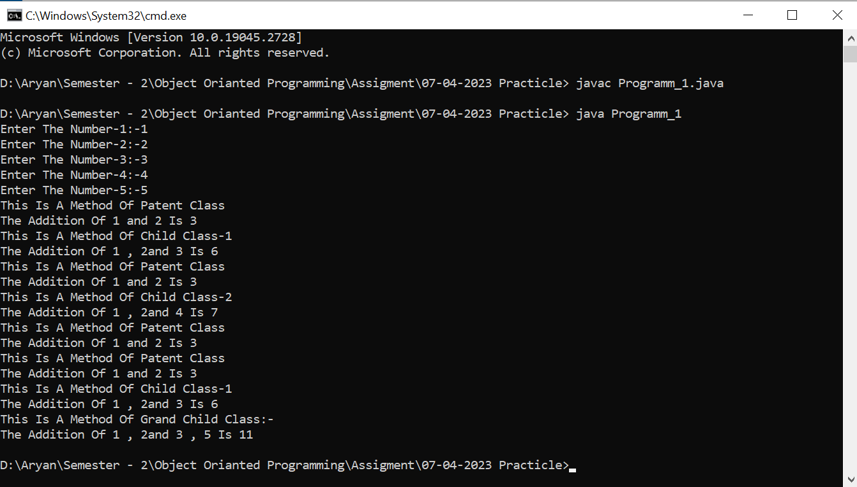

|  |  |  |
| --- | --- | --- |
| Image result for latest marwadi university logo | **Marwadi University**  **Faculty of Technology**  **Department of Information and Communication Technology** | |
| **Subject:- OOP  (01CT0105)** | **Aim:-** Write a Java Program to Implement Static method. | |
| **Experiment No:-** 7 | **Date:-**  07-04-2023 | **Enrolment No:- 92200133030** |

**Experiment – 7**

**Objective :**- Write a Java Program to Implement Static method.

**Code:-**

import java.util.*;

class LCM {

public static int cal(int num1,int num2) {

if(num2 == 0) { return num1 ; }

else

{ return cal(num2,num1%num2) ; } }}

public class Programm_2

{ public static void main(String[] args) {

Scanner sc = new Scanner(System.in) ;

int num1 ,num2 ;

System.out.print("Enter The First Number:-");

num1 = sc.nextInt();

System.out.print("Enter The Second Number:-");

num2 = sc.nextInt() ;

int Add = (num1 * num2) / (LCM.cal(num1,num2) ) ;

System.out.println("The LCM Of " + num1 + " and " + num2 + " Is " + Add);

sc.close();

}

}

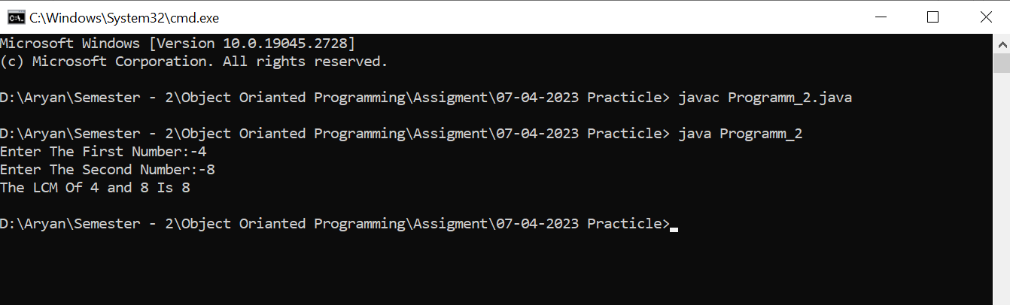**Output:-**

|  |  |  |
| --- | --- | --- |
| Image result for latest marwadi university logo | **Marwadi University**  **Faculty of Technology**  **Department of Information and Communication Technology** | |
| **Subject:- OOP  (01CT0105)** | **Aim:-** Write a java program for Constructor overloading | |
| **Experiment No:-** 8 | **Date:-**  24-03-2023 | **Enrolment No:- 92200133030** |

**Experiment – 8**

**Objective :**- Write a java program for Constructor overloading

**Code:-**

import java.util.*;

class Class {

String Name;

long Roll_No ;

int GR_No;

Class() { }

Class(String Name, long Roll_No,int GR_No) {

this.Name = Name;

this.Roll_No = Roll_No ;

this.GR_No = GR_No ;

System.out.println("Parameterized Constructor:-");

System.out.println("Student Details:-\n" + "Name:- " + this.Name + "\nRoll- No:- "+this.Roll_No + "\nSalary:- " + this.GR_No); }

Class(Class c1) {

System.out.println("Copy Constructor:-");

System.out.println("Student Details:-\n" + "Name:- " + c1.Name + "\nRoll- No:- "+c1.Roll_No + "\nSalary:- " + c1.GR_No); } }

public class Programm_5 {

public static void main(String args[]) {

Scanner sc = new Scanner (System.in) ;

Class c1 = new Class() ;

System.out.print("Enter Your Name:-");

c1.Name = sc.nextLine() ;

System.out.print("Enter Your Roll-No:-");

c1.Roll_No = sc.nextLong();

System.out.print("Enter Your GR No:-");

c1.GR_No = sc.nextInt();

Class c2 = new Class(c1.Name,c1.Roll_No,c1.GR_No) ;

Class c3 = new Class(c2); } }

**Output:-**

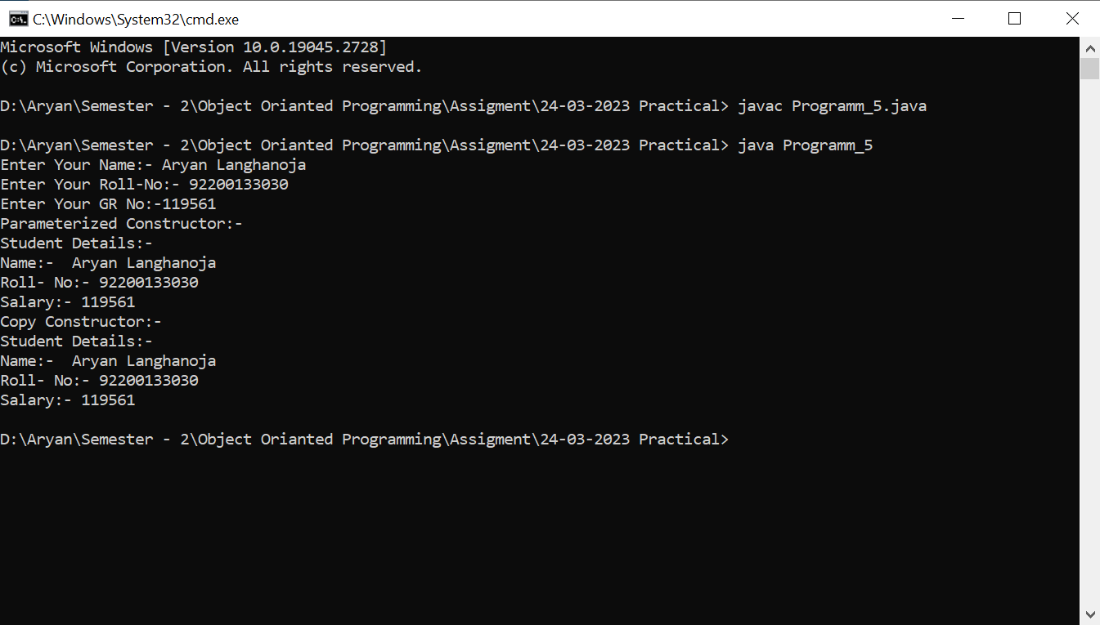

|  |  |  |
| --- | --- | --- |
| Image result for latest marwadi university logo | **Marwadi University**  **Faculty of Technology**  **Department of Information and Communication Technology** | |
| **Subject:- OOP  (01CT0105)** | **Aim:-** Write a java program to represent Abstract class with example | |
| **Experiment No:-** 9 | **Date:-**  28-04-2023 | **Enrolment No:- 92200133030** |

**Experiment – 9**

**Objective :**- Write a java program to represent Abstract class with example

**Code:-**

import java.util.* ;

abstract class Shape{

void getArea(){ }}

class Square extends Shape{

public double length;

public void getArea(){

System.out.println("The Area Of Square Is " + (this.length * this.length));

}}

class Rectangle extends Shape{

public double length ;

public double breadth ;

public void getArea(){

System.out.println("The Area Of Square Is " + (this.breadth * this.length));

}}

class Circle extends Shape{

public double Radius ;

public void getArea(){

System.out.println("The Area Of Circle Is " + (3.14159 * this.Radius * this.Radius));

}}

public class Programm_1{

public static void main(String[] args) {

Scanner sc = new Scanner(System.in) ;

int num ;

System.out.println("Enter The Number According You Will Get Area:-\n1-Square\n2-Rectangle\n3-Circle");

num = sc.nextInt() ;

Square square = new Square();

Rectangle rectangle = new Rectangle() ;

Circle circle = new Circle() ;

if(num == 1){

System.out.println("Enter The Length Of A Side Of A Square:-");

square.length = sc.nextInt();

square.getArea();}

else if(num == 2){

System.out.println("Enter The Length Of A Rectangle");

rectangle.length = sc.nextInt();

System.out.println("Enter The Breadth Of A Rectangle");

rectangle.breadth = sc.nextInt() ;

rectangle.getArea();}

else if(num == 3){

System.out.println("Enter The Radius Of A Circle:-");

circle.Radius = sc.nextInt();

circle.getArea();}

else{

System.out.println("Enter The Valid Input");

}

sc.close();}}

**Output:-**

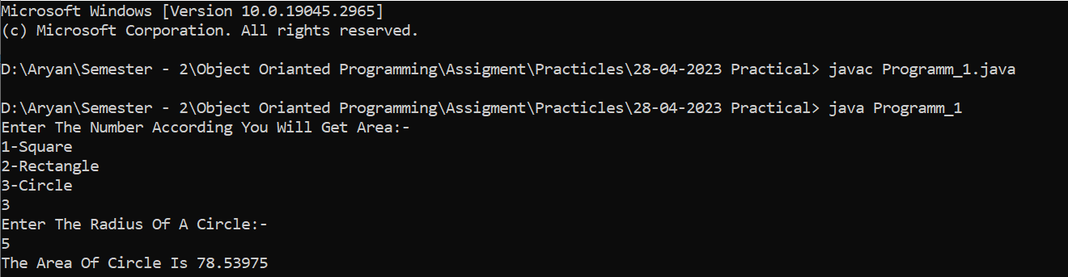

|  |  |  |
| --- | --- | --- |
| Image result for latest marwadi university logo | **Marwadi University**  **Faculty of Technology**  **Department of Information and Communication Technology** | |
| **Subject:- OOP  (01CT0105)** | **Aim:-** Write a java program to implement Interface using extends keyword. | |
| **Experiment No:-** 10 | **Date:-**  03-03-2023 | **Enrolment No:- 92200133030** |

**Experiment – 10**

**Objective :**- Write a java program to implement Interface using extends keyword.

**Code:-**

import java.util.*;

interface Shape{

public void getArea() ;}

interface Circumference extends Shape{

public void getCircumference() ;}

class Square implements Circumference

{ public double length;

public void getArea(){

System.out.println("The Area Of Square Is " + (this.length * this.length));}

public void getCircumference(){

System.out.println("The CIrcumference Is " + (4 *this.length));}}

class Rectangle implements Circumference{

public double length ;

public double breadth ;

public void getArea(){

System.out.println("The Area Of Square Is " + (this.breadth * this.length));

}public void getCircumference(){

System.out.println("The Circumference Of Rectangle Is " + (2*(this.length + this.breadth))); }}

class Circle implements Circumference{

public double Radius ;

public void getArea(){

System.out.println("The Area Of Circle Is " + (3.14159 * this.Radius * this.Radius));

}public void getCircumference(){

System.out.println("The Circumference OF A Circle Is " + (2 * 3.14159 * this.Radius));

}}

public class Programm_2 {

public static void main(String[] args) {

Scanner sc = new Scanner(System.in) ;

int num ;

System.out.println("Enter The Number According You Will Get Area:-\n1-Square\n2-Rectangle\n3-Circle");

num = sc.nextInt() ;

Square square = new Square();

Rectangle rectangle = new Rectangle() ;

Circle circle = new Circle() ;

if(num == 1){

System.out.println("Enter The Length Of A Side Of A Square:-");

square.length = sc.nextInt();

square.getArea();

square.getCircumference();}

else if(num == 2){

System.out.println("Enter The Length Of A Rectangle");

rectangle.length = sc.nextInt();

System.out.println("Enter The Breadth Of A Rectangle");

rectangle.breadth = sc.nextInt() ;

rectangle.getArea();

rectangle.getCircumference();

}else if(num == 3){

System.out.println("Enter The Radius Of A Circle:-");

circle.Radius = sc.nextInt();

circle.getArea();

circle.getCircumference();

}

else{

System.out.println("Enter The Valid Input"); }

sc.close();}}

**Output:-**

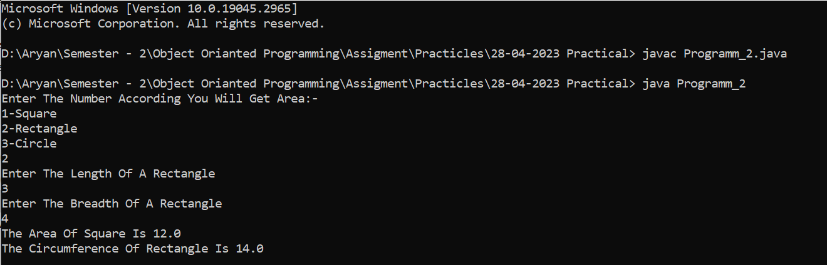

|  |  |  |
| --- | --- | --- |
| Image result for latest marwadi university logo | **Marwadi University**  **Faculty of Technology**  **Department of Information and Communication Technology** | |
| **Subject:- OOP  (01CT0105)** | **Aim:-** Write a Java program to implement multiple inheritance using interface. | |
| **Experiment No:-** 11 | **Date:-**  03-03-2023 | **Enrolment No:- 92200133030** |

**Experiment – 11**

**Objective :**- Write a Java program to implement multiple inheritance using interface.

**Code:-**

interface Parent_Class_1{ void sum(int a,int b);}

interface Parent_Class_2 { void sum(int a,int b); }

class Child_Class implements Parent_Class_1 , Parent_Class_2{

public void sum(int a,int b){

System.out.println(a +" + " + b + " = " + (a+b));}}

public class Programm_3{

public static void main(String[] args) {

Child_Class c1 = new Child_Class() ;

c1.sum(5,6) ;

c1.sum(6, 7); }}

**Output:-**

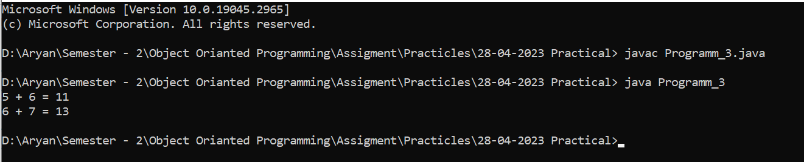

|  |  |  |
| --- | --- | --- |
| Image result for latest marwadi university logo | **Marwadi University**  **Faculty of Technology**  **Department of Information and Communication Technology** | |
| **Subject:- OOP  (01CT0105)** | **Aim:-** Write a Java program to show the difference between interface and abstract class. | |
| **Experiment No:-** 12 | **Date:-**  03-03-2023 | **Enrolment No:- 92200133030** |

**Experiment – 12**

**Objective :**- Write a Java program to show the difference between interface and abstract class.

**Code:-**

import java.util.*;

interface Interface{

public void sum();

public void sup();}

class Interface_Class implements Interface{

int a;

int b;

public void sum(){

System.out.println("Addition of " + this.a + " and " + this.b + " is " + (this.a + this.b));}

public void sup(){

System.out.println("Substraction of " + this.a + " and " + this.b + " is " + (this.a - this.b)); }}

abstract class Abstract_Class {

public void sum(){}

public void sup(){} }

class Abstract_Child_Class extends Abstract_Class {

int a;

int b;

public void sum(){

System.out.println("Addition of " + this.a + " and " + this.b + " is " + (this.a + this.b));}

public void sup(){

System.out.println("Substraction of " + this.a + " and " + this.b + " is " + (this.a - this.b));}}

public class Programm_4 {

public static void main(String[] args) {

Scanner sc= new Scanner(System.in) ;

Abstract_Child_Class Abs = new Abstract_Child_Class();

Interface_Class Int = new Interface_Class() ;

System.out.println("Enter The Value Of A:-");

Abs.a = sc.nextInt() ;

System.out.println("Enter The Value Of B:-");

Abs.b = sc.nextInt() ;

Int.a = Abs.a ;

Int.b = Abs.b ;

Abs.sum();

Abs.sup();

Int.sum();

Int.sup();

sc.close(); }}

**Output:-**

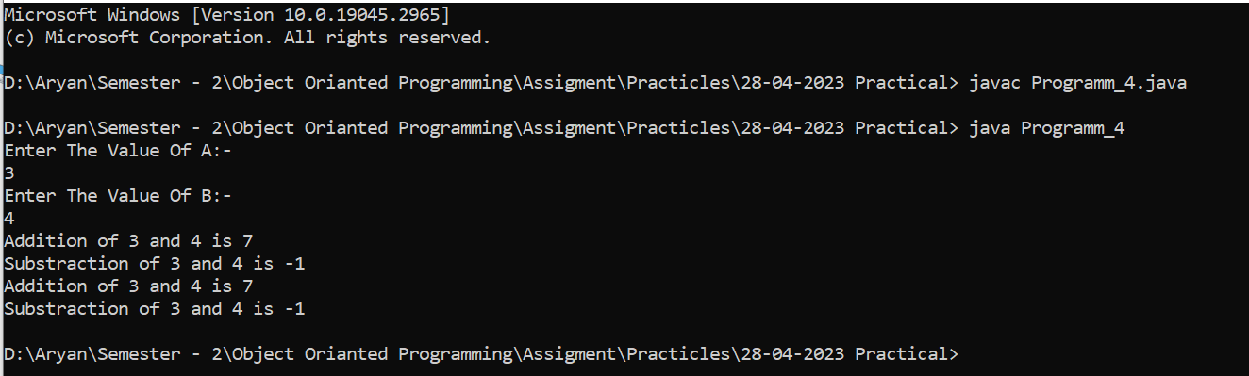

|  |  |  |
| --- | --- | --- |
| Image result for latest marwadi university logo | **Marwadi University**  **Faculty of Technology**  **Department of Information and Communication Technology** | |
| **Subject:- OOP  (01CT0105)** | **Aim:-** Write a Java program to implement 1D Array. | |
| **Experiment No:-** 13 | **Date:-**  03-03-2023 | **Enrolment No:- 92200133030** |

**Experiment – 13**

**Objective :**- Write a Java program to implement 1D Array.

**Code:-**

public class Programm_1 {

public static void main(String[] args) {

int[] arr = new int[10] ;

for(int i=0;i<10;i++){

arr[i] = i ;}

for(int i=0;i<10;i++){

System.out.println("arr[" + i + "] = " + arr[i]);

} } }

**Output:-**

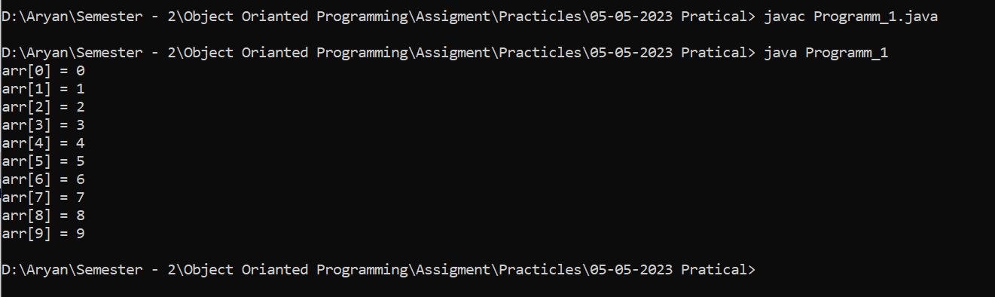

|  |  |  |
| --- | --- | --- |
| Image result for latest marwadi university logo | **Marwadi University**  **Faculty of Technology**  **Department of Information and Communication Technology** | |
| **Subject:- OOP  (01CT0105)** | **Aim:-** Write a Java program to implement 2D Array. | |
| **Experiment No:-** 14 | **Date:-**  03-03-2023 | **Enrolment No:- 92200133030** |

**Experiment – 14**

**Objective :**-Write a Java program to implement 2D Array.

**Code:-**

public class Programm_2 {

public static void main(String[] args){

int[][] arr = new int[2][5] ;

int var = 0;

for(int i=0;i<2;i++){

for(int j=0;j<5;j++){

arr[i][j] = var ;

var++; }}

for(int i=0;i<2;i++){

for(int j=0;j<5;j++){

System.out.println("arr[" + i + "][" + j + "] = " + arr[i][j]);

}}}}

**Output:-**

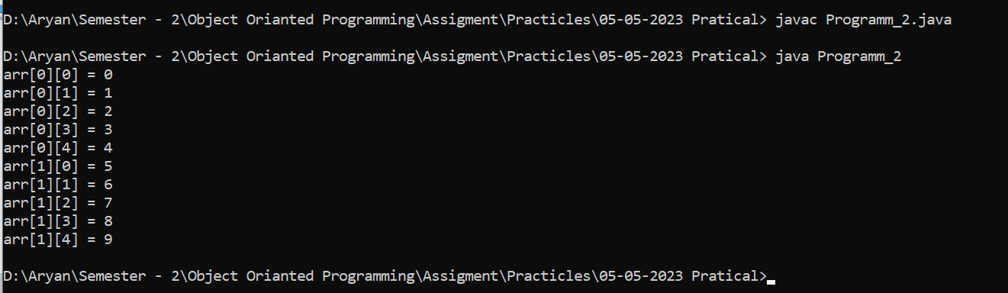

|  |  |  |
| --- | --- | --- |
| Image result for latest marwadi university logo | **Marwadi University**  **Faculty of Technology**  **Department of Information and Communication Technology** | |
| **Subject:- OOP  (01CT0105)** | **Aim:-** Write a Java program to insert an element in 1D Array. | |
| **Experiment No:-** 15 | **Date:-**  03-03-2023 | **Enrolment No:- 92200133030** |

**Experiment – 15**

**Objective :**- Write a Java program to insert an element in 1D Array.

**Code:-**

import java.util.*;

public class Programm_3 {

public static void main(String[] args) {

Scanner sc= new Scanner(System.in);

int arr[] = new int[10] ;

for(int i=0;i<10;i++) {

System.out.println("Enter The Number At arr[" + i + "] :-");

arr[i] = sc.nextInt() ; }

for(int i=0;i<10;i++) {

System.out.println("arr[" + i + "] = " + arr[i]);

}

sc.close(); }}

**Output:-**

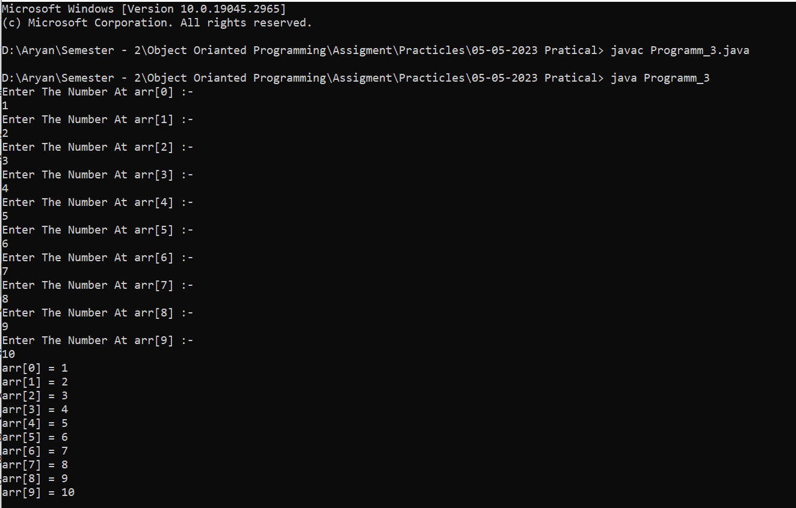

|  |  |  |
| --- | --- | --- |
| Image result for latest marwadi university logo | **Marwadi University**  **Faculty of Technology**  **Department of Information and Communication Technology** | |
| **Subject:- OOP  (01CT0105)** | **Aim:-** Write a Java program to delete an element from 1D Array. | |
| **Experiment No:-** 16 | **Date:-**  03-03-2023 | **Enrolment No:- 92200133030** |

**Experiment – 16**

**Objective :**-Write a Java program to delete an element from 1D Array.

**Code:-**

import java.util.*;

public class Programm_4 {

public static void main(String[] args) {

Scanner sc= new Scanner(System.in);

int arr[] = new int[10] ;

int del ;

for(int i=0;i<10;i++){

System.out.println("Enter The Number At arr[" + i + "] :-");

arr[i] = sc.nextInt() ; }

System.out.println("Enter the Index You Want To Delete:-");

del = sc.nextInt();

arr[del] = 0 ;

for(int i=0;i<10;i++){

System.out.println("arr[" + i + "] = " + arr[i]);}

sc.close();}}

**Output:-**

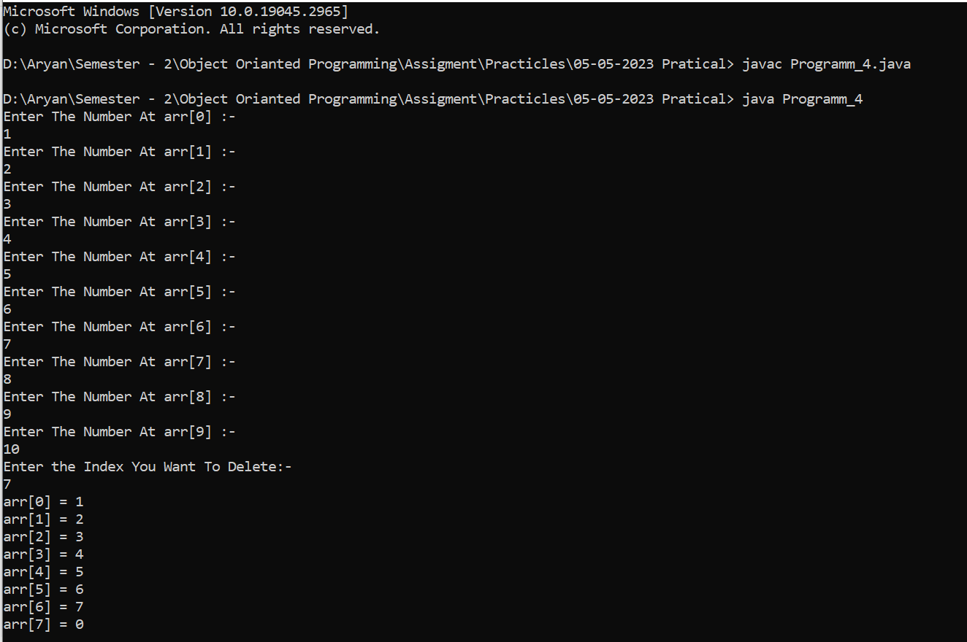

|  |  |  |
| --- | --- | --- |
| Image result for latest marwadi university logo | **Marwadi University**  **Faculty of Technology**  **Department of Information and Communication Technology** | |
| **Subject:- OOP  (01CT0105)** | **Aim:-** Write a java program to create user defined package. Import Package and Use it functionality in another Java File. | |
| **Experiment No:-** 17 | **Date:-**  03-03-2023 | **Enrolment No:- 92200133030** |

**Experiment – 17**

**Objective :**- Write a java program to create user defined package. Import Package and Use it functionality in another Java File.

**Code:-**

package Packeges_My;

public class MyPackage {

public static int sum(int a, int b) {

return (a + b); }}

import Packeges_My.*;

public class Main {

public static void main(String[] args) {

int a = 5;

int b = 5;

System.out.println(MyPackage.sum(a,b)); }}

**Output:-**

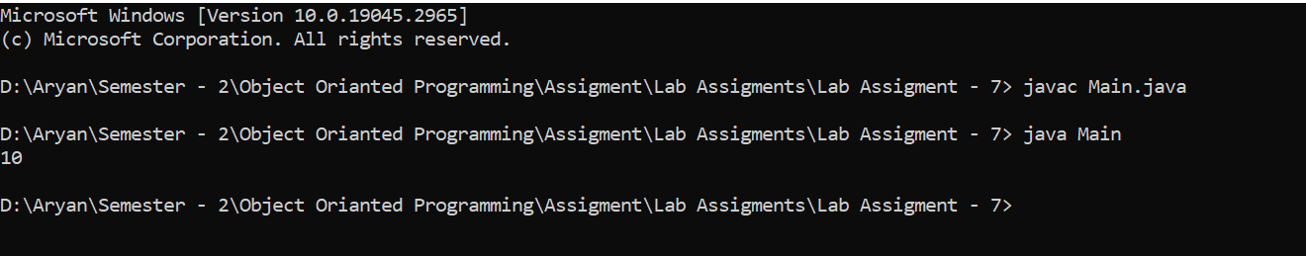

|  |  |  |
| --- | --- | --- |
| Image result for latest marwadi university logo | **Marwadi University**  **Faculty of Technology**  **Department of Information and Communication Technology** | |
| **Subject:- OOP  (01CT0105)** | **Aim:-** Write a Java Program to demonstrate Exception Handling using try, catch and finally. | |
| **Experiment No:-** 18 | **Date:-**  03-03-2023 | **Enrolment No:- 92200133030** |

**Experiment – 18**

**Objective :**- Write a Java Program to demonstrate Exception Handling using try, catch and finally.

**Code:-**

import java.util.*;

public class My_Exception{

public static void main(String[] args)

Scanner sc = new Scanner(System.in);

System.out.println("Enter The Number - 1 :-");

int a = sc.nextInt();

try{

int b;

System.out.println("Enter The Number - 2 :-");

b = sc.nextInt();

int c = a / b ;}

catch (Exception e) {

System.out.println("Can't Divide By Zero.");}

Finally {

System.out.println("Programm Ends");

}}}

**Output:-**

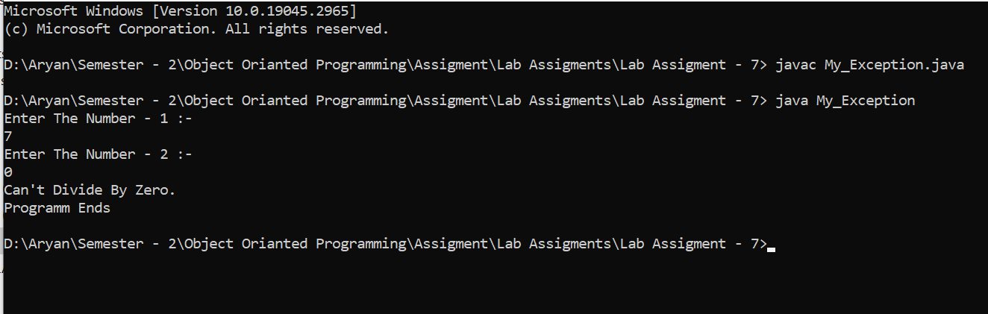

|  |  |  |
| --- | --- | --- |
| Image result for latest marwadi university logo | **Marwadi University**  **Faculty of Technology**  **Department of Information and Communication Technology** | |
| **Subject:- OOP  (01CT0105)** | **Aim:-** Write a Custom Exception and Use it. | |
| **Experiment No:-** 19 | **Date:-**  03-03-2023 | **Enrolment No:- 92200133030** |

**Experiment – 19**

**Objective :**- Write a Custom Exception and Use it.

**Code:-**

import java.util.*;

class Custom_Ex extends Exception {

Custom_Ex() {

System.out.println("Custom Exception Occurs"); } }

public class Custom {

public static void main(String[] args) {

Scanner sc = new Scanner (System.in) ;

int a , b ;

System.out.println("Enter The Number:-");

a = sc.nextInt();

System.out.println("Enter The Second Number:-");

b = sc.nextInt();

if( b == 0) {

try { throw new Custom_Ex(); }

catch (Exception My_Exception) {

System.out.println("Can't Divide By Zero"); }}

System.out.println("Answer :- " + (a/b)); } }

**Output:-**

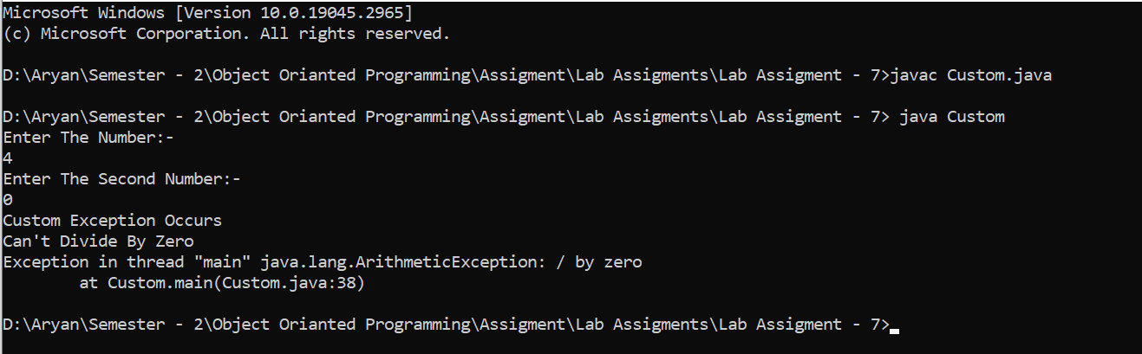

|  |  |  |
| --- | --- | --- |
| Image result for latest marwadi university logo | **Marwadi University**  **Faculty of Technology**  **Department of Information and Communication Technology** | |
| **Subject:- OOP  (01CT0105)** | **Aim:-** Write a java program that implements a multi-thread application that has three threads. First thread generates random integer every 1 second and if the value is even, second thread computes the square of the number and prints. If the value is odd, the third thread will print the value of cube of the number. | |
| **Experiment No:-** 20 | **Date:-**  03-03-2023 | **Enrolment No:- 92200133030** |

**Experiment – 20**

**Objective :**- Write a java program that implements a multi-thread application that has three threads. First thread generates random integer every 1 second and if the value is even, second thread computes the square of the number and prints. If the value is odd, the third thread will print the value of cube of the number.

**Code:-**

import java.util.Random;

class RandomNumberGenerator implements Runnable {

public void run() {

Random random = new Random();

int num = 0;

while (num<=10) {

int number = random.nextInt(100);

System.out.println("Generated number: " + number);

if (number % 2 == 0) {

Thread squareThread = new Thread(new SquareCalculator(number));

squareThread.start(); }

else {

Thread cubeThread = new Thread(new CubeCalculator(number));

cubeThread.start();}

try {Thread.sleep(1000); }

catch (InterruptedException e) {

e.printStackTrace(); }

num ++;} } }

class SquareCalculator implements Runnable {

private int number;

public SquareCalculator(int number) {

this.number = number; }

public void run() {

int square = number * number;

System.out.println("Square of " + number + " is: " + square); } }

class CubeCalculator implements Runnable {

private int number;

public CubeCalculator(int number) {

this.number = number; }

public void run() {

int cube = number * number * number;

System.out.println("Cube of " + number + " is: " + cube); } }

public class Table {

public static void main(String[] args) {

Thread generatorThread = new Thread(new RandomNumberGenerator());

generatorThread.start(); } }

**Output:-**

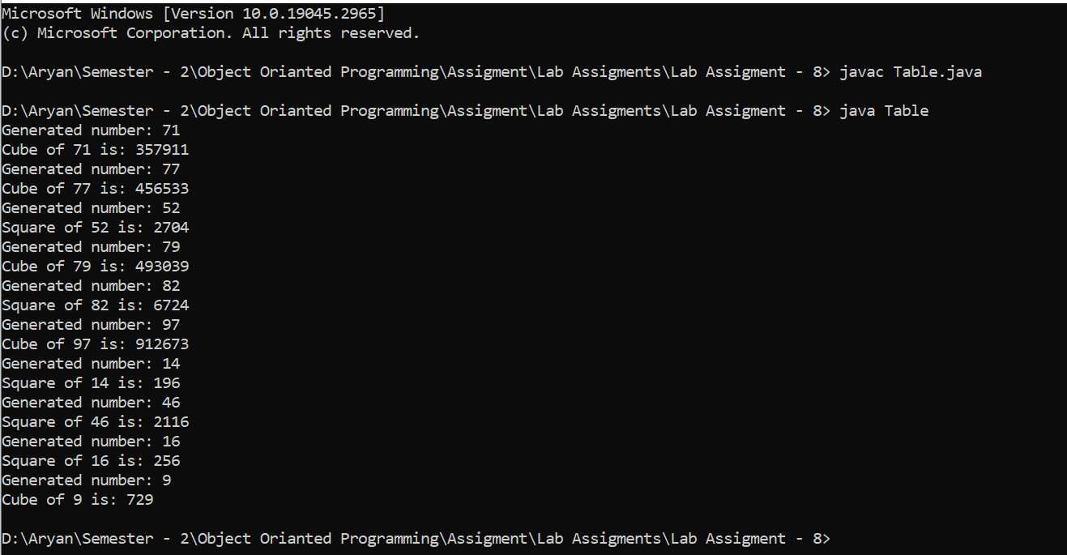

|  |  |  |
| --- | --- | --- |
| Image result for latest marwadi university logo | **Marwadi University**  **Faculty of Technology**  **Department of Information and Communication Technology** | |
| **Subject:- OOP  (01CT0105)** | **Aim:-** Write a Java program to implement Collection Framework | |
| **Experiment No:-** 21 | **Date:-**  03-03-2023 | **Enrolment No:- 92200133030** |

**Experiment – 21**

**Objective :**- Write a Java program to implement Collection Framework

**Code:-**

import java.util.ArrayList;

import java.util.LinkedList;

public class CF {

public static void main(String[] args) {

ArrayList<String> arrayList = new ArrayList<>();

arrayList.add("Apple");

arrayList.add("Banana");

arrayList.add("Orange");

System.out.println("ArrayList elements: " + arrayList);

LinkedList<Character> linkedList = new LinkedList<>();

linkedList.add('A');

linkedList.add('B');

linkedList.add('C');

System.out.println("LinkedList elements: " + linkedList); } }

**Output:-**

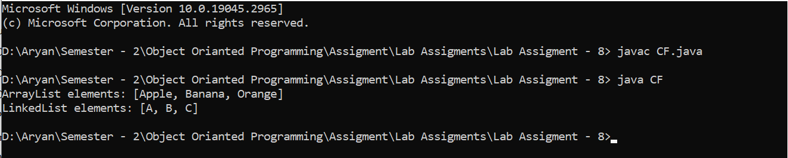

|  |  |  |
| --- | --- | --- |
| Image result for latest marwadi university logo | **Marwadi University**  **Faculty of Technology**  **Department of Information and Communication Technology** | |
| **Subject:- OOP  (01CT0105)** | **Aim:-** Write a Java program that reads a file and displays the file on the screen, with a line number before each line. | |
| **Experiment No:-** 22 | **Date:-**  03-03-2023 | **Enrolment No:- 92200133030** |

**Experiment – 22**

**Objective :**- Write a Java program that reads a file and displays the file on the screen, with a line number before each line.

**Code:-**

import java.io.BufferedReader;

import java.io.FileReader;

import java.io.IOException;

public class File_Read {

public static void main(String[] args) {

try (BufferedReader reader = new BufferedReader(new FileReader("ABC.txt"))) {

String line;

int lineNumber = 1;

while ((line = reader.readLine()) != null) {

System.out.printf("%d: %s%n", lineNumber, line);

lineNumber++; } }

catch (IOException e) {

System.out.println("An error occurred while reading the file: " + e.getMessage());

}}}

**Output:-**

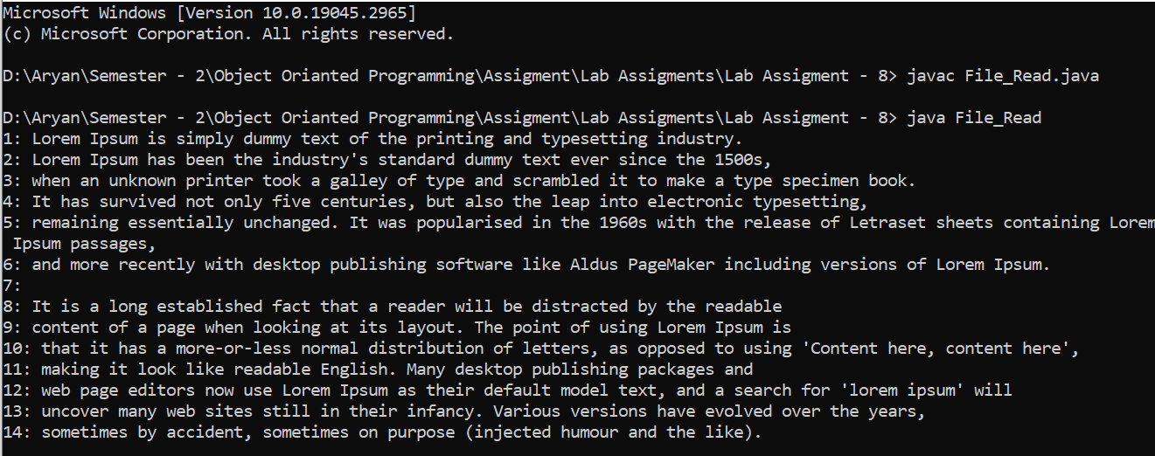

|  |  |  |
| --- | --- | --- |
| Image result for latest marwadi university logo | **Marwadi University**  **Faculty of Technology**  **Department of Information and Communication Technology** | |
| **Subject:- OOP  (01CT0105)** | **Aim:-** Develop an AWT/SWING program that receives an integer in one text field & compute its factorial value & returns it in another text filed when the button “Computer” is clicked | |
| **Experiment No:-** 23 | **Date:-**  03-03-2023 | **Enrolment No:- 92200133030** |

**Experiment – 23**

**Objective :**- Develop an AWT/SWING program that receives an integer in one text field & compute its factorial value & returns it in another text filed when the button “Computer” is clicked

**Code:-**

import java.awt.*;

import java.awt.event.*;

import javax.swing.*;

public class FactorialCalculator extends JFrame implements ActionListener {

private JTextField inputField;

private JTextField outputField;

private JButton computeButton;

public FactorialCalculator() {

setTitle("Factorial Calculator");

setDefaultCloseOperation(JFrame.EXIT_ON_CLOSE);

setSize(300, 150);

setLocationRelativeTo(null);

inputField = new JTextField(10);

outputField = new JTextField(10);

outputField.setEditable(false);

computeButton = new JButton("Compute");

computeButton.addActionListener(this);

JPanel panel = new JPanel();

panel.add(new JLabel("Enter an integer:"));

panel.add(inputField);

panel.add(computeButton);

panel.add(new JLabel("Factorial value:"));

panel.add(outputField);

setContentPane(panel); }

public void actionPerformed(ActionEvent e) {

if (e.getSource() == computeButton) {

String input = inputField.getText();

try {

int number = Integer.parseInt(input);

long factorial = computeFactorial(number);

outputField.setText(String.valueOf(factorial)); }

catch (NumberFormatException ex) {

outputField.setText("Invalid input"); } } }

private long computeFactorial(int number) {

long factorial = 1;

for (int i = 2; i <= number; i++) {factorial *= i; }

return factorial;}

public static void main(String[] args) {

SwingUtilities.invokeLater(() -> {

FactorialCalculator calculator = new FactorialCalculator();

calculator.setVisible(true);

}); }}

**Output:-**

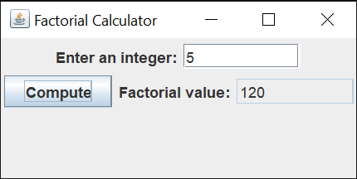

|  |  |  |
| --- | --- | --- |
| Image result for latest marwadi university logo | **Marwadi University**  **Faculty of Technology**  **Department of Information and Communication Technology** | |
| **Subject:- OOP  (01CT0105)** | **Aim:-** Write a java program that simulates a traffic light. The program lets the user select one of three lights: red, yellow, or green with radio buttons. On selecting a button, an appropriate message with “stop” or “ready” or “go” should appear above the buttons in a selected color. Initially there is no message shown. | |
| **Experiment No:-** 24 | **Date:-**  03-03-2023 | **Enrolment No:- 92200133030** |

**Experiment – 24**

**Objective :**- Write a java program that simulates a traffic light. The program lets the user select one of three lights: red, yellow, or green with radio buttons. On selecting a button, an appropriate message with “stop” or “ready” or “go” should appear above the buttons in a selected color. Initially there is no message shown.

**Code:-**

import java.awt.*;

import java.awt.event.*;

import javax.swing.*;

public class TrafficLightSimulation extends JFrame implements ActionListener {

private JLabel label;

public TrafficLightSimulation() {

setTitle("Traffic Light Simulation");

setSize(300, 400);

setDefaultCloseOperation(JFrame.EXIT_ON_CLOSE);

setLayout(new FlowLayout());

JRadioButton redButton = new JRadioButton("Red");

redButton.setActionCommand("stop");

redButton.addActionListener(this);

JRadioButton yellowButton = new JRadioButton("Yellow");

yellowButton.setActionCommand("ready");

yellowButton.addActionListener(this);

JRadioButton greenButton = new JRadioButton("Green");

greenButton.setActionCommand("go");

greenButton.addActionListener(this);

ButtonGroup buttonGroup = new ButtonGroup();

buttonGroup.add(redButton);

buttonGroup.add(yellowButton);

buttonGroup.add(greenButton);

label = new JLabel();

label.setPreferredSize(new Dimension(200, 100));

add(redButton);

add(yellowButton);

add(greenButton);

add(label);

setVisible(true); }

public void actionPerformed(ActionEvent e) {

String command = e.getActionCommand();

String message = "";

if (command.equals("stop")) {

label.setForeground(Color.RED);

message = "Stop";

} else if (command.equals("ready")) {

label.setForeground(Color.YELLOW);

message = "Ready";

} else if (command.equals("go")) {

label.setForeground(Color.GREEN);

message = "Go";

}

label.setText(message);

}

public static void main(String[] args)

{

SwingUtilities.invokeLater(new Runnable() {

public void run() {

new TrafficLightSimulation();

}

});

}

}

**Output:-**

